API Server

🌐 What is an API Server
# Source: AI Source: Provided by: [Data Path: Persons Table -> ID Column: 1, Name_En Column: Motasem Essam] -> From: [ChatGPT] on [1/19/2026]
An API Server is the backend system that hosts the API, processes requests from clients, executes business logic, accesses databases or services, and returns responses.
👉 Think of the API Server as the “brain” of your API — it receives requests, makes decisions, and sends back data.

🔑 Key Responsibilities of an API Server
# Source: AI Source: Provided by: [Data Path: Persons Table -> ID Column: 1, Name_En Column: Motasem Essam] -> From: [ChatGPT] on [1/19/2026]
- Receive Requests
  - Accepts HTTP requests from API clients through defined endpoints
- Process Requests
  - Validates input
  - Authenticates users
  - Calls business logic or services
- Access Resources
  - Reads/writes data via Repositories or databases
  - Communicates with other services if needed
- Send Responses
  - Returns structured data (JSON, XML)
  - Sets proper status codes and response headers
- Handle Errors & Security
  - Returns meaningful error messages
  - Protects against unauthorized access

🧱 Example: API Server Flow
# Source: AI Source: Provided by: [Data Path: Persons Table -> ID Column: 1, Name_En Column: Motasem Essam] -> From: [ChatGPT] on [1/19/2026]
Client Request:
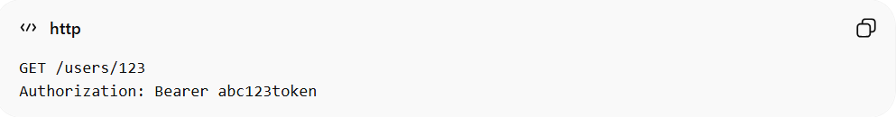
GET /users/123
Authorization: Bearer abc123token
Server Actions:
- Validate request & token
- Call UserService.getUserById(123)
- Fetch user from repository/database
- Format response as JSON
- Return 200 OK with user data
Response:
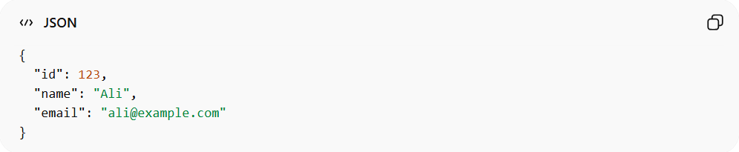
{
"id": 123,
"name": "Ali",
"email": "ali@example.com"
}

✅ Good Practices
# Source: AI Source: Provided by: [Data Path: Persons Table -> ID Column: 1, Name_En Column: Motasem Essam] -> From: [ChatGPT] on [1/19/2026]
- Keep business logic in Service/Repository, not directly in server code
- Return consistent and meaningful responses
- Implement authentication and authorization
- Ensure scalability and statelessness for multiple clients

❌ Common Mistakes
# Source: AI Source: Provided by: [Data Path: Persons Table -> ID Column: 1, Name_En Column: Motasem Essam] -> From: [ChatGPT] on [1/19/2026]
- Putting all logic in the server endpoints ❌
- Returning raw database objects ❌
- Ignoring security, rate-limiting, or validation ❌

💡 Summary
# Source: AI Source: Provided by: [Data Path: Persons Table -> ID Column: 1, Name_En Column: Motasem Essam] -> From: [ChatGPT] on [1/19/2026]
The API Server is the central system that handles API requests, executes logic, accesses data, and sends back structured responses to clients.

